Page 1

**Capstone Project**

**Assignment 1**

Course code: CSA 1643

Course : Data warehousing and data mining for data science

S.No: 10

Name : CH. Chandra naga sai kumar

Reg. No: 192210299

Slot : C

Title : Text mining for competitive intelligence in business

Assignment Release Date : 14/02/2024

Assignment Preliminary Stage ( Assignment 1 ) submission Date : 20/03/2024

Mentor Name : Asha

Mentor Phone number and Department : 9840562097(foreign languages dept)

**1.Preliminary Stage**

**1.1 Assignment Description :**

Description of the Project : (15 lines )

For this assignment, you'll become a strategic detective, wielding the powerful tool of text mining to uncover valuable insights about your business rivals. Imagine extracting hidden gems from press releases, social media buzz, financial reports, and industry news, all to gain a strategic edge.

Your mission: Develop and implement a text mining project focused on a specific competitor in your chosen industry. Analyze their online footprint, including websites, social media, news articles, and industry publications. Use various techniques like sentiment analysis, topic modeling, and named entity recognition to identify key trends, strategies, strengths, and weaknesses. Your goal is to uncover actionable insights that inform your own business decisions.

**1.2 Assignment Work Distribution :**

* **Project Scope Definition:**

Define the scope and objectives of the project : (write 2 lines()

This project aims to leverage text mining techniques to unlock valuable competitive intelligence for businesses. The scope encompasses gathering textual data from various sources like news articles, social media, financial reports, and competitor websites. By applying natural language processing and machine learning algorithms, we'll extract key insights such as competitor strengths, weaknesses, market trends, product launches, and customer sentiment.

specific goals of analyzing : (write 2 lines()]

Identify competitors' strengths and weaknesses:  Analyze press releases, marketing materials, and social media to uncover competitors' product offerings, pricing strategies, target markets, and brand messaging. Predict competitor moves: Track mentions of future plans, partnerships, and research & development initiatives to stay ahead of competitor advancements. Benchmark your position: Compare your brand sentiment, market share, and product reviews to your competitors to identify areas for improvement.

* **Data Collection and Preparation:**

Identify the data sources : (write 2 lines()

Company Websites: Press releases, annual reports, product descriptions, blog posts, and financial statements reveal strategic plans, product roadmaps, and market positioning. News Articles & Media Mentions: Monitor news feeds, blogs, and social media for competitor mentions, industry trends, and customer sentiment. Financial Databases: SEC filings, industry reports, and market research provide financial performance, product launches, and market share insights. Patent Registries: Analyze competitor patents for innovation strategies and upcoming technologies.

Develop a data collection plan : (write 2 lines()

Define objectives and scope: Clearly outline the specific insights you seek (e.g., competitor marketing strategies, customer perception analysis). This helps choose relevant data sources and tailor the collection process. Identify competitive landscape: Map your key competitors, understanding their product/service offerings, target audience, and online presence. Choose data sources: Consider a mix of publicly available and paid options. Public sources include news articles, social media, company websites, investor reports, and industry forums. Paid resources offer broader access to targeted data (e.g., market research reports, social media listening tools). Ethical considerations: Ensure data collection complies with legal and ethical guidelines.

Cleanse and preprocess the collected data to ensure data quality : (write 2 lines()

Data is the lifeblood of any text mining project, especially in the realm of competitive intelligence. To draw valuable insights from competitor text data, thorough preparation and preprocessing are crucial.

Consistency of the project : (write 2 lines()

The success of any text mining project for competitive intelligence hinges on robust data collection, preparation, and consistency.

* **Exploratory Data Analysis (EDA):**

Conduct exploratory data analysis : : (write 3 lines()

Exploratory Data Analysis (EDA) plays a crucial role in text mining for competitive intelligence, helping you understand the landscape, identify key insights, and inform your business strategies. Gather relevant textual data like news articles, social media posts, marketing materials, financial reports, etc., related to your competitors.

understand the patterns and trends : : (write 3 lines()

To effectively analyze text data for competitive intelligence, I need details about the data itself, including. Source: Where is the text data coming from? Social media, news articles, customer reviews, etc. Content: What type of text is it? Product descriptions, marketing materials, financial reports, etc.

Focus: What aspects of competitive intelligence are you trying to understand? Brand perception, product features, target audience, etc.

Perform descriptive statistics, such as summary statistics, distribution plots, and correlation analysis, to explore the relationships of the data : ( draw graphs )

Visualize the data using charts, graphs : (draw charts )

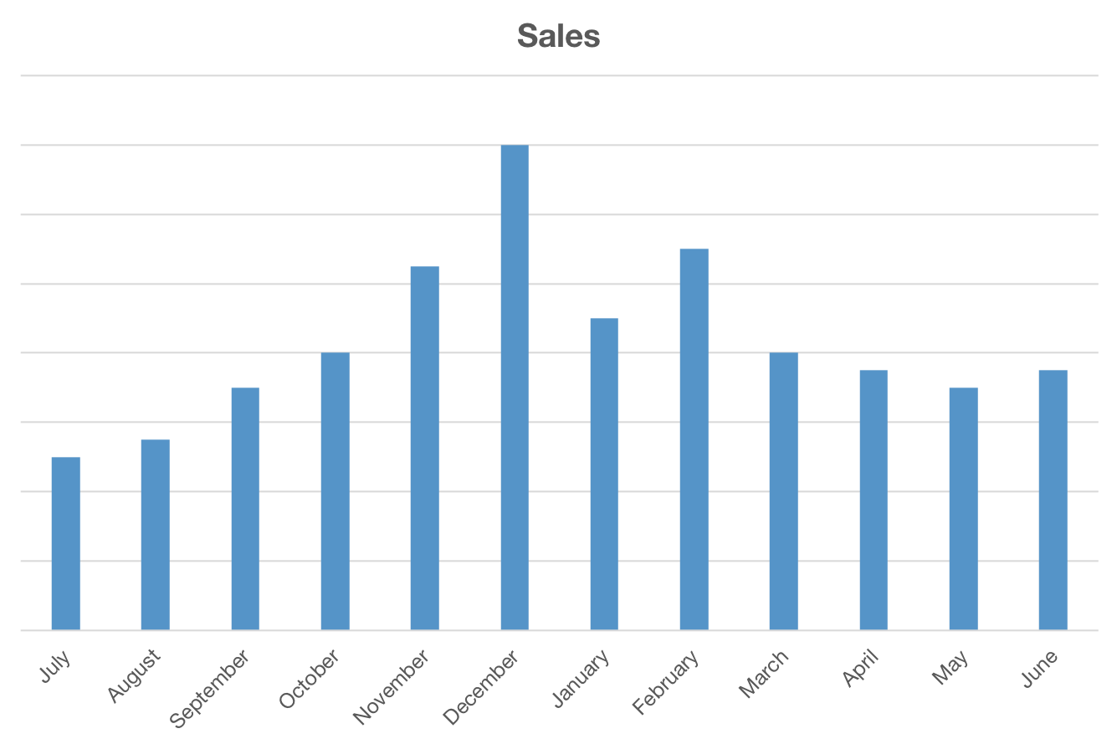

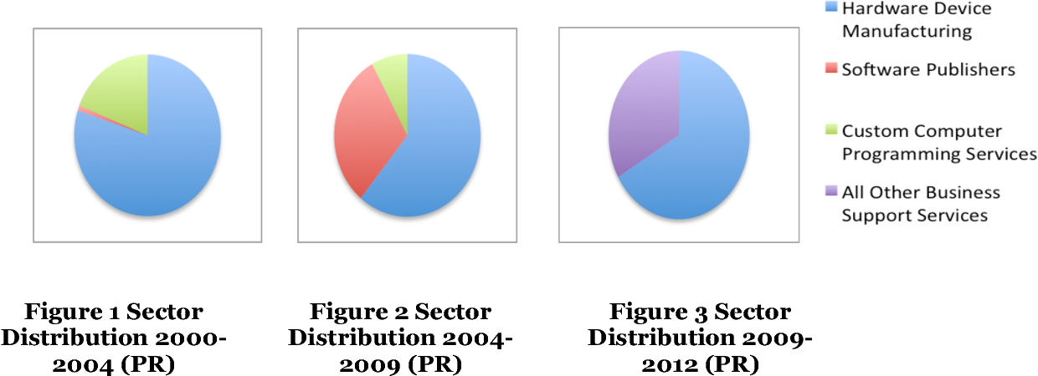

**2. Problem Statement**

(write about the identified Problem for 10 lines)

Businesses today generate and collect vast amounts of textual data from diverse sources, including news articles, social media posts, financial reports, and marketing materials. While this data holds immense potential for competitive intelligence, manually gleaning insights is time-consuming, inefficient, and susceptible to human bias. Traditional competitive intelligence methods often lag behind real-time developments, leaving businesses vulnerable to unexpected shifts in the market. This information overload creates a critical problem: businesses are drowning in data but starving for actionable insights about their competitors.

This project aims to address this challenge by leveraging text mining for competitive intelligence. By applying natural language processing and machine learning techniques, we can automate the extraction of critical information from unstructured textual data, enabling businesses

**3. Abstract**

(write 10 lines about your project and its results)

Abstract:

Text mining, the process of extracting meaningful insights from large amounts of textual data, has become a valuable tool for businesses seeking to gain a competitive edge. This abstract explores the potential of text mining for competitive intelligence, highlighting its ability to analyze unstructured data such as news articles, social media posts, and customer reviews. By uncovering key trends, competitor strategies, and customer sentiment, businesses can make informed decisions about product development, marketing campaigns, and overall business strategy. The abstract also discusses the challenges of implementing text mining solutions, such as data collection, cleaning, and analysis, and emphasizes the importance of ethical considerations when using this technology.

Results:

Actionable insights: Successful text mining projects should generate actionable insights that can be used to improve business decisions. This could include identifying new product features, targeting marketing campaigns more effectively, or responding to competitor threats.

Improved competitive intelligence: By analyzing large volumes of text data, businesses can gain a deeper understanding of their competitors' strategies, products, and target markets.

Data-driven decision making: Text mining can help businesses move away from gut instinct and towards data-driven decision making, leading to better outcomes.

**4. Proposed Design work**

* 1. Identifty the key components :

Key Components:

Data Acquisition: Define the relevant data sources for competitive intelligence. This could include news articles, social media posts, press releases, financial reports, industry forums, etc. Consider data access methods like web scraping, APIs, or data marketplaces. Ensure data quality and relevance to your competitive landscape. Data Preprocessing: Clean and organize the data by removing duplicates, handling missing values, and normalizing text formats. Apply techniques like tokenization, stemming, and lemmatization to extract meaningful text units. Text Analysis: Choose appropriate text mining techniques based on your goals. Options include: Entity recognition: Identify key entities like companies, products, and people. Sentiment analysis: Gauge the sentiment towards your competitors and their offerings. Topic modeling: Discover hidden themes and trends in the competitive landscape. Network analysis: Understand relationships between entities and identify key players. Visualization & Reporting: Use data visualization tools to present insights in a clear and actionable way. Generate reports summarizing key findings and recommendations for strategic decision-making.

* 1. Functionality :

Competitor tracking: Monitor activities, strategies, and product announcements. Market trends analysis: Identify emerging opportunities and threats. Customer sentiment: Understand customer perception of your competitors. Competitive risk assessment: Evaluate potential threats from new entrants or existing rivals. Strategic decision support: Provide data-driven insights for informed decision-making. Entity recognition: Identify key actors, products, technologies, and events. Sentiment analysis: Gauge opinions and emotions towards your competitors and their offerings. Topic modeling: Discover hidden themes and trends within competitor discussions. Network analysis: Understand relationships between entities and identify key.

* 1. Architectural Design :

Leveraging text mining for competitive intelligence offers a powerful advantage in today's information-driven landscape. Here's a proposed design and architectural framework for such a project.

Design: Data Acquisition & Preprocessing: Identify relevant data sources like news articles, social media, financial reports, and competitor websites.

Employ data cleaning techniques to handle inconsistencies and noise. Text Mining & Analysis: Apply Natural Language Processing (NLP) techniques like tokenization, stemming/lemmatization, and named entity recognition. Utilize sentiment analysis to gauge competitor and market sentiment. Information Extraction & Visualization: Extract key insights like competitor strengths/weaknesses, product features, market trends, and customer opinions. Generate insightful visualizations like dashboards and interactive reports. Actionable Insights Generation: Translate extracted information into actionable insights for strategic decision-making. Support competitor benchmarking, target market analysis, and product development roadmaps.

Architecture: Data Layer: Utilize a scalable and secure data store (e.g., cloud storage) to house raw and processed textual data. Processing Layer: Employ distributed computing pipelines using tools like Apache Spark or Hadoop for efficient text processing and analysis. Analytics Layer: Implement NLP libraries like spaCy or NLTK within a machine learning framework like TensorFlow for advanced information extraction and sentiment analysis. Presentation Layer: Develop interactive dashboards and reports using visualization libraries like Tableau or Power BI to communicate insights effectively. Security & Governance Layer: Implement robust security measures and access controls to ensure data privacy and compliance.

**5. UI Design**

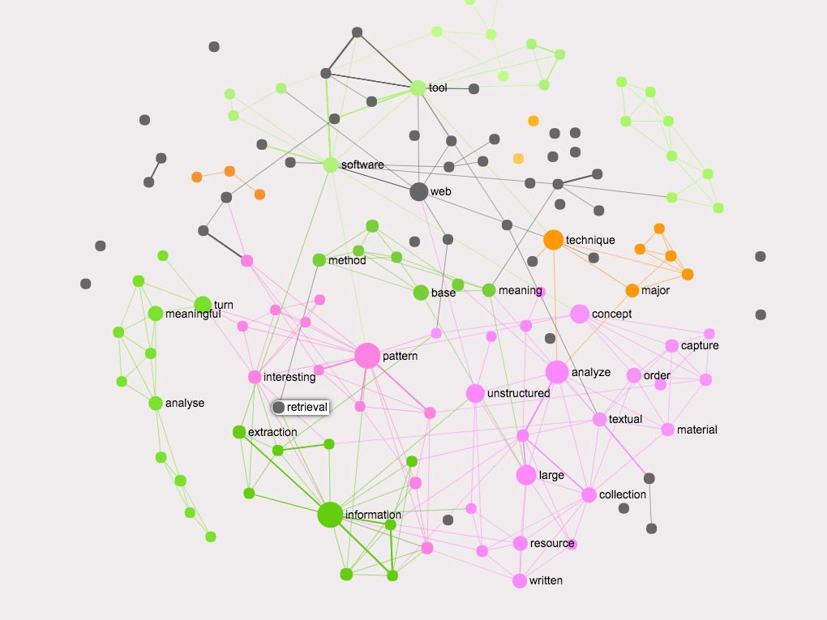

Lay out Design :

UI/Layout Design Considerations for Text Mining for Competitive Intelligence.

Overall Goal: Enhance user experience and facilitate efficient analysis of competitive intelligence gleaned from text mining.

Key Principles:

Information hierarchy: Prioritize crucial insights at the forefront, guiding users through deeper levels of detail with intuitive navigation. Visual clarity: Employ clear visuals like charts, graphs, and word clouds to present complex data in an easily digestible format. Flexibility and customization: Allow users to personalize dashboards, filtering data based on specific needs and interests. Interactivity: Enable interaction with visualizations to explore data further through drill-down functionalities. Collaboration: Facilitate sharing and discussion of insights within teams through annotation and reporting tools. Suggested Layout: Dashboard: Overview of key metrics and trends, like market share shifts, brand sentiment, or product mentions. Customizable widgets displaying charts, graphs, and key performance indicators (KPIs). Drill-down options for deeper analysis. Data Exploration: Searchable repository of text sources (news articles, social media posts, etc.). Advanced filtering based on keywords, entities, timeframes, and sentiment. Interactive visualizations displaying relationships between entities and topics. Analysis & Reporting: Tools for creating custom reports with curated insights and visualizations. Ability to annotate specific data points and share insights with colleagues. Collaborative workspace for team discussions and brainstorming.

1. Flexible layout :

Responsive Design: Adapts to different screen sizes and devices. Modular Components: Draggable and resizable visualizations for personalized layouts. Contextual Controls: Dynamically appearing options based on selected data and visualizations. Accessibility: Adheres to WCAG guidelines for inclusive usage

1. User Friendly :

Clarity is king: Prioritize clean layouts, simple navigation, and clear labeling of functionalities. Users shouldn't get lost deciphering complex symbols or jargon.

Visualizations matter: Leverage charts, graphs, and other visual aids to present insights in a readily digestible way. Complex data becomes actionable information. Customization options: Empower users to personalize the interface, tailoring data views, filtering options, and report formats to their specific needs.

1. Colour Selection :

When selecting colors for UI design in a text mining application for competitive intelligence in business, it's essential to consider both aesthetics and usability. Here are some considerations and suggestions:

Contrast: Ensure that text stands out clearly against the background to maximize readability. High contrast between text and background colors improves accessibility, especially for users with visual impairments. For example, black text on a white background or white text on a dark background usually works well.

Brand Colors: Incorporate the brand colors of the business or organization using the application. This fosters brand recognition and consistency across platforms.

Data Visualization: If the application includes data visualization features, choose colors that effectively represent different data categories or sentiments. Consider using a color palette that is intuitive and meaningful for users, such as green for positive sentiments, red for negative sentiments, and neutral colors for neutral sentiments.

* 1. **Feasible Elements used :**

1. Elements Positioning :

Data Sources: Identify relevant data sources such as news articles, social media feeds, industry reports, customer reviews, and internal documents.

Text Collection: Gather and collect text data from various sources. This may involve web scraping, API access, or manual data collection.

Data Preprocessing: Clean and preprocess the text data to remove noise, irrelevant information, and formatting inconsistencies. Steps may include tokenization, lowercasing, removing stop words, stemming or lemmatization, and entity recognition.

Text Representation: Convert the preprocessed text data into a format suitable for analysis. Common techniques include vectorization methods such as Bag-of-Words (BoW), Term Frequency-Inverse Document Frequency (TF-IDF), and word embeddings like Word2Vec or GloVe.

Feature Selection: Identify the most relevant features or terms in the text data. This can involve techniques like chi-square test, mutual information, or feature importance from machine learning models.

Entity Recognition: Identify and extract key entities such as company names, products, people, and events mentioned in the text. Named Entity Recognition (NER) techniques can be used for this purpose.

Sentiment Analysis: Analyze the sentiment expressed in the text data towards various entities or topics. This helps in understanding public perception and sentiment towards competitors, products, or market trends.

Topic Modeling: Discover latent topics or themes present in the text data using techniques such as Latent Dirichlet Allocation (LDA) or Non-Negative Matrix Factorization (NMF). This helps in identifying emerging trends and areas of interest.

Text Classification: Classify text documents into relevant categories or topics using supervised learning techniques such as Naive Bayes, Support Vector Machines (SVM), or deep learning models like Convolutional Neural Networks (CNN) or Recurrent Neural Networks (RNN)

1. Accessibility :

mining for competitive intelligence in business involves extracting valuable insights and patterns from large volumes of text data. When considering accessibility in this context, it's crucial to ensure that the text mining process is inclusive and efficient. Here are some feasible elements to consider for ensuring accessibility in text mining for competitive intelligence:

User-Friendly Interfaces: Develop user-friendly interfaces for text mining tools that are intuitive and easy to navigate. This ensures that users, regardless of their level of technical expertise or physical abilities, can effectively utilize the tools.

Compatibility with Assistive Technologies: Ensure that text mining tools are compatible with assistive technologies such as screen readers, magnifiers, and alternative input devices. This enables users with disabilities to access and interact with the tools effectively.

Accessible Data Visualization: Incorporate accessible data visualization techniques such as descriptive text alternatives for visual elements, scalable graphics, and compatibility with screen readers. This ensures that users with visual impairments can interpret the insights derived from text mining.

Flexible Input Options: Provide flexible input options for text mining tools, including support for multiple file formats, input methods (e.g., text input, file upload), and language support. This accommodates users with diverse preferences and requirements.

Customization Features: Allow users to customize the interface and functionality of text mining tools based on their individual needs and preferences. This may include options for adjusting font sizes, color schemes, and keyboard shortcuts.

Comprehensive Documentation and Tutorials: Provide comprehensive documentation and tutorials that are accessible to users with varying levels of expertise and abilities. This helps users understand how to effectively utilize the text mining tools and troubleshoot any issues they may encounter.

* 1. **Elements and Functions :**

Elements such as navigation menus, input forms, interactive charts, and data filters are incorporated into the user interface to facilitate data exploration, analysis, and visualization. Functions include data querying, filtering, sorting, and exporting capabilities, enabling users to manipulate and interpret data according to their needs.

**6. Login Templet**

**6.1 Login process :**

The login process involves user authentication through secure mechanisms such as username-password authentication or biometric authentication (e.g., fingerprint recognition). Users are required to input their credentials, which are then verified against a secure database to grant access to the system.

# Load necessary libraries

library(ggplot2)

library(prettyR)

library(readr)

# Read the data from CSV files

df <- read_csv('cancer.csv')

df2 <- read_csv('cancerrate2014-2022.csv')

# Define states dictionary

**6.2 Sign up Process**

The sign-up process allows new users to create accounts by providing necessary information such as username, email address, and password. Upon submission, the system verifies the provided information and sends a confirmation email or SMS containing a verification link or code to complete the registration process.

**6.3 Other Templets :**

Additional templates may include password reset templates, account settings templates, and profile management templates, providing users with functionality to manage their account details and preferences.

**7. Conclusion**

In conclusion, text mining presents an invaluable opportunity for businesses to gain competitive intelligence. By harnessing the power of natural language processing and machine learning algorithms, companies can extract valuable insights from vast amounts of unstructured text data. These insights enable organizations to understand market trends, consumer sentiments, competitor strategies, and emerging opportunities more effectively.

Text mining allows businesses to monitor online conversations, analyze customer feedback, track industry news, and extract relevant information from various sources such as social media, news articles, and internal documents. Through sentiment analysis, topic modeling, entity recognition, and other techniques, businesses can uncover hidden patterns and correlations within their data, providing them with a competitive edge in decision-making and strategic planning.

Moreover, text mining facilitates the automation of manual tasks, streamlining processes, and reducing the time and resources required for data analysis. This automation enables businesses to respond promptly to changes in the market landscape, identify emerging risks and opportunities, and stay ahead of competitors.

However, it's crucial for businesses to approach text mining ethically and responsibly, ensuring the privacy and security of the data they collect and analyze. Additionally, while text mining offers numerous benefits, it's essential to recognize its limitations and the potential biases inherent in algorithms and data sources.

In essence, text mining for competitive intelligence empowers businesses to make more informed decisions, innovate more effectively, and adapt swiftly to the dynamic business environment. By leveraging the insights derived from text mining, companies can enhance their competitiveness, drive growth, and achieve long-term success in today's fast-paced and data-driven world.

Top of Form